Applications of Photodiode

* Photodiodes are used in simple day-to-day applications. The reason for their prominent use is their linear response of photodiode to light illumination.
* Photodiodes with the help of optocouplers provide electric isolation. When two isolated circuits are illuminated by light, optocouplers are used to couple the circuit optically. Optocouplers are faster compared to conventional devices.
* Photodiodes are used in safety electronics such as fire and smoke detectors.
* Photodiodes are used in numerous medical applications. They are used in instruments that analyze samples, detectors for computed tomography and also used in blood gas monitors.
* Photodiodes are used in solar cell panels.
* Photodiodes are used in logic circuits.
* Photodiodes are used in the detection circuits.
* Photodiodes are used in character recognition circuits.
* Photodiodes are used for the exact measurement of the intensity of light in science and industry.
* Photodiodes are faster and more complex than normal PN junction diode and hence are frequently used for lighting regulation and optical communication.

## What is a depletion region?

When the p-type and the n-type materials are kept in contact with each other, the junction between them behaves differently from either side of the material alone. The electrons and holes are close to each other at the junction. According to coulomb’s law, there is a force between the negative electrons and the positive holes. When the p-n junction is formed a few electrons from the n-type diffuse through the junction and combines with the holes in the p-side to form negative ions and leaves behind positive ions in the n-side. This results in the formation of the depletion layer, which acts as the barrier and does not allow any further flow of electrons from the n region to the p region.

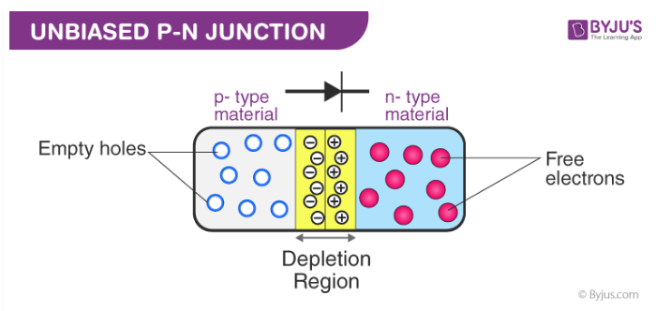

## Forward Bias and Reverse Bias

In the forward bias, the p side of the diode is connected to the positive side of the battery and the n side is connected to the negative side of the battery. The direction of the applied voltage is opposite to the junction barrier potential. Therefore, the size of the depletion region decreases. Therefore, the voltage applied in the forward direction assists the electrons in the n region to overcome the barrier and flow to the p region.

When the p-side is connected to the negative terminal and n-side is connected to the positive terminal of the battery, it is called reverse biased. When a reverse bias is applied, free electrons are pulled away from the junction, which results in the increase of the width and resistance of the depletion region.

Comparison of Halfwave and full wave rectifier?

| **PARAMETERS** | **HALF-WAVE RECTIFIERS** | **FULL-WAVE RECTIFIERS** |
| --- | --- | --- |
| Rectification Efficiency | 40.6% | 81.2% |
| Ripple Factor | 1.21 | 0.482 |
| Transformer Utilization Factor | 0.286 | 0.692 |
| Voltage Regulation | Good | Better |
| Fundamental frequency of ripple | Equal to Supply Frequency, f | Double of Supply Frequency, 2f |
| Form Factor | 1.57 | 1.11 |
| Peak Factor | 2 | 1.414 |
| Number of diodes | Only 1 | Vary from 2 to 4, 4 in case of bridge rectifier |
| Peak Inverse Voltage | Vs | 2 Vs |
| DC Output Voltage | Imax/π RL | 2/π RL Imax |

# **Junction Diode as a rectifier**

The process in which alternating voltage or alternating current is converted into a direct voltage or direct current is known as **rectification**. The device used for this process is called as a **rectifier**. The junction diode has the property of offering low resistance and allowing current to flow through it, in the forward biased condition. This property is used in the process of rectification.

## Half wave rectifier:

A circuit which rectifies half of the a.c wave is called half wave rectifier.

### What is a Tunnel Diode?

A Tunnel Diode is a heavily doped p-n junction diode. The tunnel diode shows negative resistance. When voltage value increases, current flow decreases. Tunnel diode works based on Tunnel Effect.

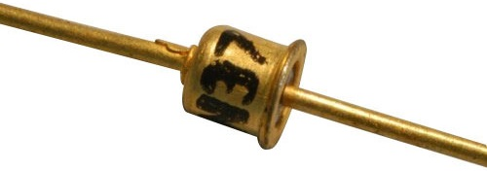

The following image shows the symbol of a Tunnel Diode.

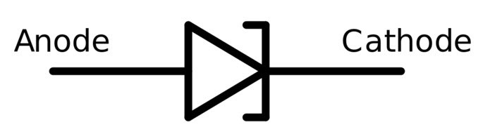

Leo Esaki invented Tunnel diode in August 1957. Therefore, it is also called as Esaki diode. The materials used for this diode are Germanium, Gallium arsenide and other silicon materials. Tunnel diode shows a negative resistance in their operating range. So, it can be used as amplifier, oscillators and in any switching circuits.

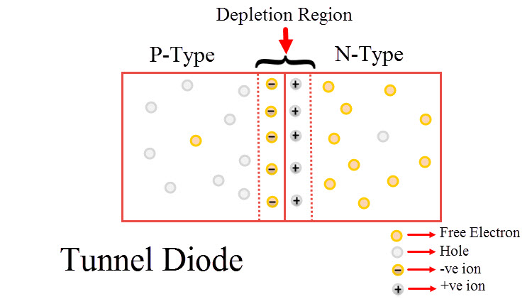

### Width of the Depletion Region in Tunnel Diode

When mobile charge carriers both free electrons and holes are missing, the region in a p-n junction has a region called Depletion region. To stop the flow of electrons from the n-type semiconductor and holes from the p-type semiconductor, depletion region acts as a barrier.

Depending on the number of impurities added, width of depletion region varies. To increase electrical conductivity of the p-type and n-type semiconductor impurities are added. A wide and big depletion region is formed when a smaller number of impurities is added to p-n junction diode. At the same time, when a greater number of impurities is added, narrow depletion region occurs.

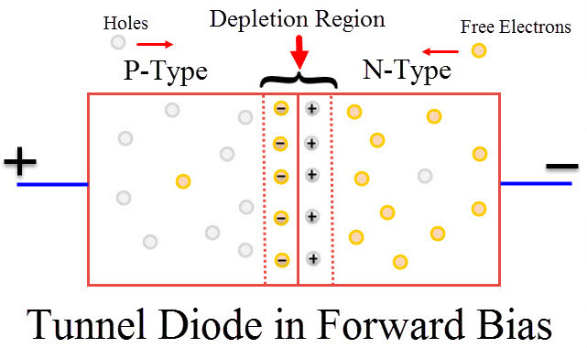

The p-type and n-type semiconductor is heavily doped in a tunnel diode due to a greater number of impurities. Heavy doping results in a narrow depletion region. When compared to a normal p-n junction diode, tunnel diode has a narrow depletion width. Therefore, when small amount of voltage is applied, it produces enough electric current in the tunnel diode.

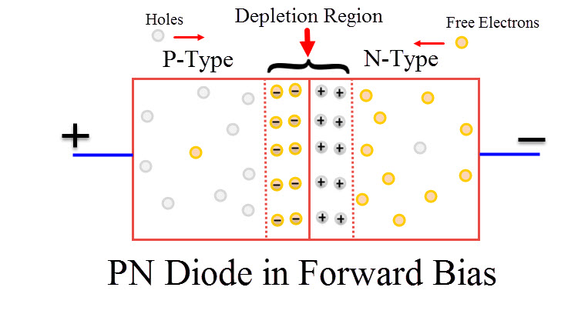

### Tunneling Effect

In electronics, Tunneling is known as a direct flow of electrons across the small depletion region from n-side conduction band into the p-side valence band. In a p-n junction diode, both positive and negative ions form the depletion region. Due to these ions, in-built electric potential or electric field is present in the depletion region. This [electric field](https://www.electronicshub.org/basics-of-electric-field/) gives an electric force to the opposite direction of externally applied voltage.

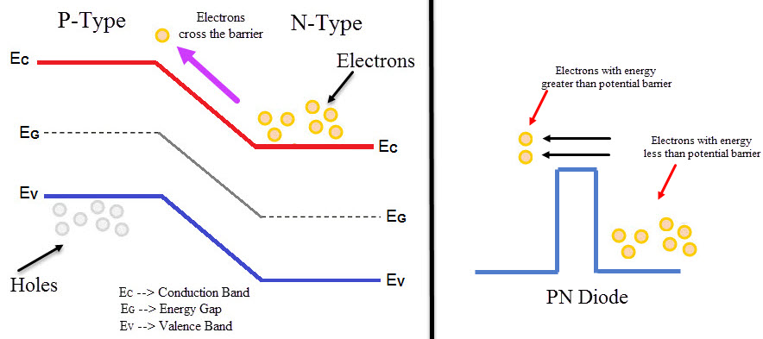

As the width of the depletion layer reduces, charge carriers can easily cross the junction. Charge carriers do not need any form of kinetic energy to move across the junction. Instead, carriers punch through junction. This effect is called Tunneling and hence the diode is called Tunnel Diode.

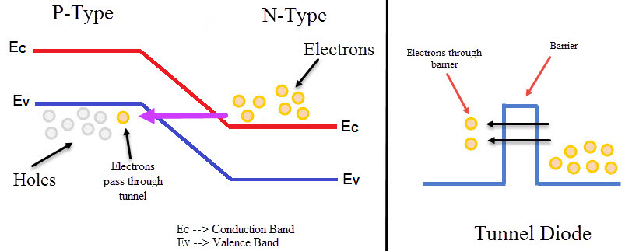

Due to Tunneling, when the value of forward voltage is low value of forward current generated will be high. It can operate in forward biased as well as in reverse biased. Due to high doping, it can operate in reverse biased. Due to the reduction in barrier potential, the value of reverse breakdown voltage also reduces. It reaches a value of zero. Due to this small reverse voltage leads to diode breakdown. Hence, this creates negative resistance region.

### Tunnel Diode Working Phenomenon

#### Unbiased Tunnel Diode

In an unbiased tunnel diode, no voltage will be applied to the tunnel diode. Here, due to heavy doping conduction band of n – type semiconductor overlaps with valence band of p – type material. Electrons from n side and holes from p side overlap with each other and they will be at same energy level.

Some electrons tunnel from the conduction band of n-region to the valence band of p-region when temperature increases. Similarly, holes will move from valence band of p-region to the conduction band of n-region. Finally, the net current will be zero since equal numbers of electrons are holes flow in opposite direction.

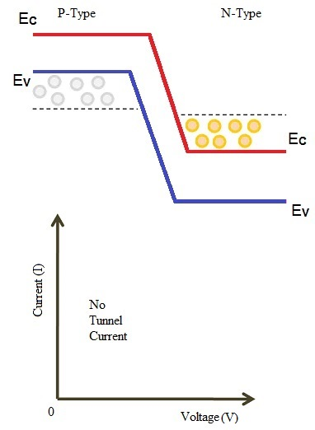

P α e (-A *E *b *W)

P – Probability that the particle crosses the barrier

W – Width of the barrier

E – Energy of the barrier

#### Small Voltage Applied to the Tunnel Diode

When a small voltage, that has lesser value than the built-in voltage of the depletion layer, is applied to the tunnel diode, there is no flow of forward current through the junction. Nevertheless, a minimal number of electrons from the conduction band of n region will start tunneling to valence band in p region.

Therefore, this movement creates a small forward biased tunnel current. When a small voltage is applied, tunnel current starts to flow.

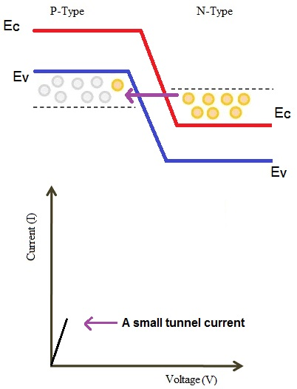

#### Increased Voltage Applied to the Tunnel Diode

When the amount of voltage applied is increased, the number of free electrons generated at n side and holes at p side is also increased. Due to voltage increase, overlapping between the bands are also increased.

Maximum tunnel current flows when the energy level of n-side conduction band and the energy level of a p-side valence band becomes equal.

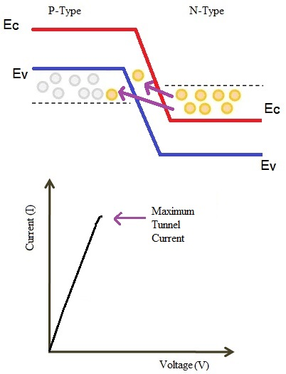

#### Further Increased Voltage Applied to the Tunnel Diode

A further increase in the applied voltage will cause a slight misalignment of the conduction band and valence band. Still there will be an overlap between conduction band and valence band. The electrons move from conduction band to valence band of p region. Therefore, this causes small current to flow. Hence, tunnel current starts decreasing.

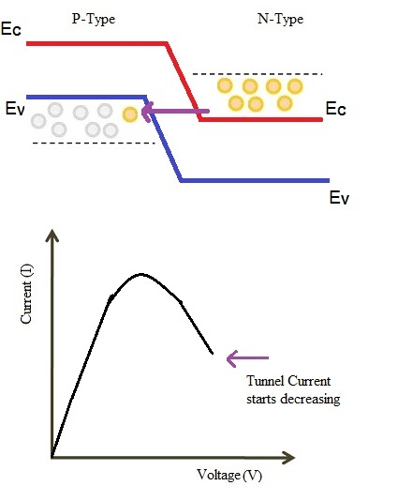

#### Largely Increased Voltage Applied to the Tunnel Diode

The tunneling current will be zero when applied voltage is increased more to the maximum. At this voltage levels, the valence band and the conduction band does not overlap. This makes tunnel diode to operate same as a PN junction diode.

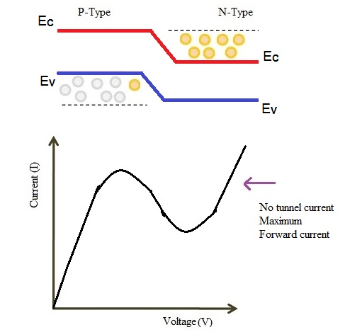

When applied voltage is more than the built-in potential of the depletion layer the forward current starts flowing through the tunnel diode. In this condition, current portion in the curve decreases when the voltage increases and this is the negative resistance of tunnel diode. Such diodes operating in negative resistance region is used as amplifier or oscillator.

### V-I Characteristics of Tunnel Diode

Due to forward biasing, because of heavy doping conduction happens in the diode. The maximum current that a diode reaches is Ip and voltage applied is Vp. The current value decreases, when more amount of voltage is applied. Current keeps decreasing until it reaches a minimal value.

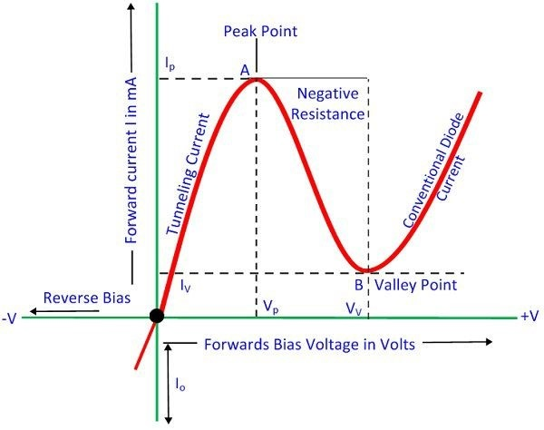

The small minimal value of current is Iv. From the above graph, it is seen that from point A to B current reduces when voltage increases. That is the negative resistance region of diode. In this region, tunnel diode produces power instead of absorbing it.

### Applications of Tunnel Diode

* Tunnel diode can be used as a switch, amplifier, and oscillator.
* Since it shows a fast response, it is used as high frequency component.
* Tunnel diode acts as logic memory storage device.
* They are used in oscillator circuits, and in FM receivers. Since it is a low current device, it is not used more.

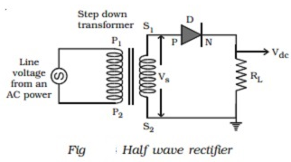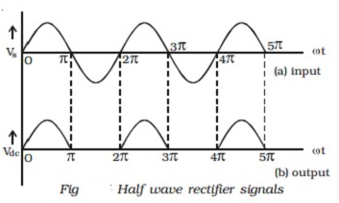

Fig shows the circuit for half wave rectification. The a.c. voltage (Vs) to be rectified is obtained across the secondary ends S1 S2 of the transformer. The P-end of the diode D is connected to S1 of the secondary coil of the transformer. The N-end of the diode is connected to the other end S2 of the secondary coil of the transformer, through a load resistance RL. The rectified output voltage Vdc appears across the load resistance RL.

During the **positive half cycle** of the input a.c. voltage Vs, S1 will be positive and the diode is forward biased and hence it conducts. Therefore, current flows through the circuit and there is a voltage drop across RL. This gives the output voltage as shown in Fig.

During the **negative half cycle** of the input a.c. voltage (Vs), S1 will be negative and the diode D is reverse biased. Hence the diode does not conduct. No current flows through the circuit and the voltage drop across RL will be zero. Hence no output voltage is obtained. Thus corresponding to an alternating input signal, the unidirectional pulsating output is obtained.

The ratio of d.c. power output to the a.c. power input is known as rectifier efficiency. The efficiency of half wave rectifier is approximately 40.6%.